Year 8 Materials and Substances Learning Journey
Lesson Remember this!
Elements= made of one thing, compounds= made of 2 or more things joined, mixtures= 2 or more things not joined
Mixtures are made from 2 or more substances that are not joined
Mixtures can be formed by a solid dissolving in a liquid

Changing temperature can affect how much solid can dissolve in a liquid
Increasing the temperature of water affects how much solid will dissolve in it
A compound is made when elements join in a chemical reaction
Lavoisier showed that oxygen joins with substances when they burn so they increase in mass
New substances are made in chemical reactions
Reactions can involve making of new substances
Chemical reactions can be slow or fast
Compounds consist of 2 or more elements chemically joined
Some materials are made of elements or compounds and some are made of mixtures
1- Classify substances as elements, compounds or mixtures
2- Use the particle model to describe elements, compounds and mixtures
3- Separating a mixture

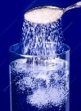
4- Investigate how temperature affects how well solids dissolve
5- Collect results and calculate a mean

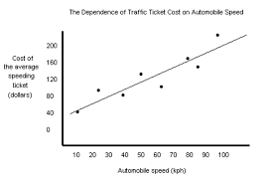
6- Draw a graph of results and write a conclusion

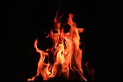
7- Substances increase in mass when you burn them

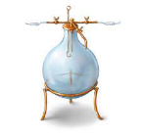
8- Investigate burning and the work of Lavoisier
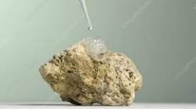
9- Learn how limestone and acid react
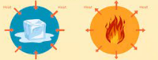
10- Learn about exothermic and endothermic reactions
11- Catalysts can speed up a reaction

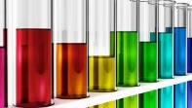
12- Learn about acids and alkalis

13- Learn about polymers, ceramics and composites

