Year 8 - Body Systems 2 Learning Journey
Lesson | Oi! Remember this!
1.) Structure and function of the Lungs.
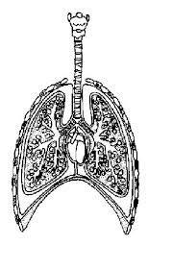 | The lungs are formed from tubes that end on air sacs where gases are exchanged.
2.) Understanding breathing and Respiration.
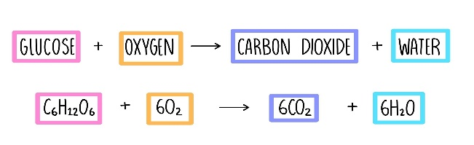 | Respiration is the chemical reaction which releases energy from food.
3.) Describe food as an energy source.
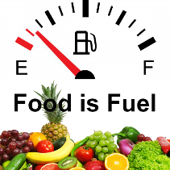  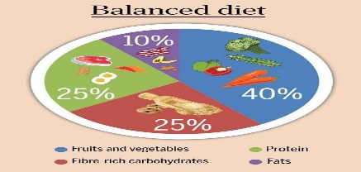 | Food is a chemical potential energy store.
4.) Describe a balanced diet.
 | A balanced diet means that you have not too much nor too little of any of the food groups.
5.) Define the main food groups.
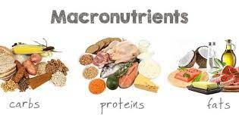  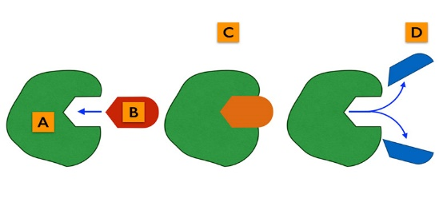 | These are Carbohydrates (energy), Proteins (growth and repair), Fats (energy), Vitamins and Minerals.
6.) Explain Enzyme function.
 | Enzyme are specific due to the specific shape of their active site.
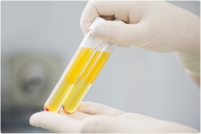
7.) Investigate conditions that effect Enzyme action.
 | Enzymes will denature if too hot – the active site is damaged.
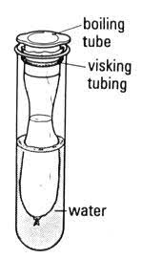
8.) Investigate a model gut.
 | Visking tubing is the intestine, water outside is the blood, starch is undigested food and glucose is the smaller, digested food.
10.)Synoptic Assessment

