Year 7 - Body Systems Learning Journey
Lesson | Oi! Remember this!
1.) Characteristics of living things
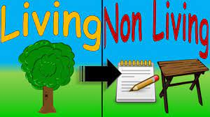 | M.R.S. G.R.E.N and there are organs for each one.
2.) Structure and function of Plants
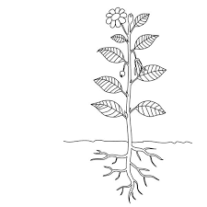 | Plant organs include; stem, roots, leaves, flowers.
3.) Structure and function of the lungs
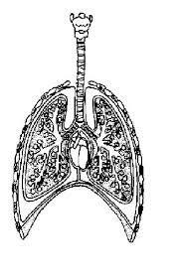 | The lungs are tubes which end in air sacs where gases are swapped.
4.) Structure of the Heart
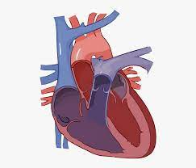 | The heart is a four chambered pump. Left is oxygenated and to the body.
5.) Structure of Blood Vessels
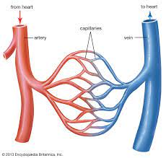 | Wide arteries away, capillaries single cell think, veins have valves and back to the heart.
6&7.) How the Digestive Systems works.
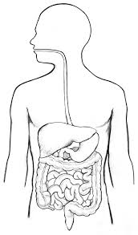 | Mechanical then chemical digestion and then absorption.
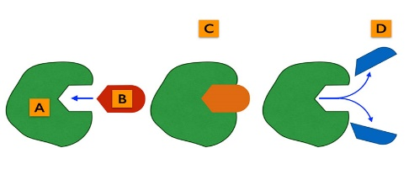
8.) Digestive Enzymes.
 | Enzymes break down specific food groups.
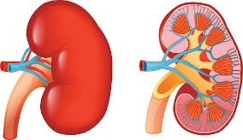
9.) Structure of the Kidneys.
 | The Kidneys clean/filter the blood.
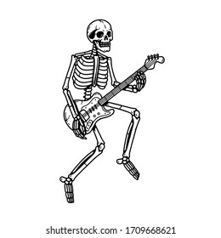
10.) Structure of the skeleton.
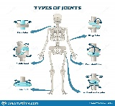 | Provides protection, support and allows movement. Hollow tubes = light and strong.
11.) How joints work.
 | Anywhere where bones meet; immovable through to freely moveable.
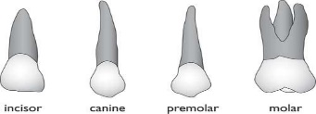
12.) Parts and types of teeth
 | Incisors (nibble), canines (kill), premolars (slice) and molars (grind)
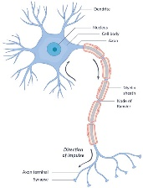
13.) Describe how we respond to stimuli
 | Receptors – to nerve – to the brain – nerve – to the muscles/glands.
14.)Synoptic Assessment

