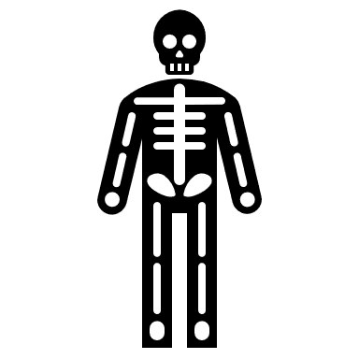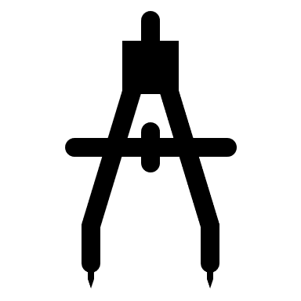

**12/13. Evaluation, Dirt and Gallery virtual visit**

Skills:

Personal response

**11. Completion of outcome**

Skills:

Personal response

Mark-making

Mixed media

**10. Personal response outcome**

Skills:

Personal response

Mark-making

Large artwork

**9.** **Design sheet for protest posters**

Skills:

Observation

Mark-making

Personal response

**8. Dirt and Artist research: Shepard Fairey linking with typography**

Skills:

Artist work

Typography

Personal response

**7. Painting ceramic sweets**

Skills:

Ceramic painting

Colour mixing

Personal response

**6. Sweet Drawing and evaluation**

Skills:

Observation

mark-making

Personal response

**5. Sweet Drawing**

Skills:

Observation

mark-making

Personal response

**3. Ceramic sweets**

Skills:

Ceramic sweet

Health and Safety

Personal response

**4. DIRT and Ceramic sweet/ Sweet drawing**-

Skills:

Ceramics

Drawing

Personal response

**2 Sweets photography and ceramic work**

Skills:

Ceramic

Personal response

**1.** **Artist study: Sarah Graham**

Skills:

Artist’s work

Observation

Personal response

Learning Journey- *Year 9 Art Term 3&4*