Year 9 Metals and Acids Learning Journey
Lesson Remember this!
Many substances can react with acids

Some substances can neutralise acids

Some substances react with acids to form a neutral solution with a pH of 7
Acids react with metals, carbonates and bases to form a salt
Substances take part in chemical reactions and form new products
The pop test is used to identify hydrogen; carbon dioxide will turn limewater cloudy; oxygen will re-light a glowing splint
Everything you have learned in the last 7 lessons

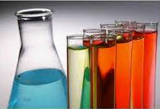
1- Learn about the pH of acids, alkalis and neutral solutions
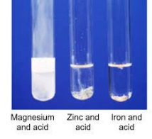
2- Learn how metals react with acids

3- Learn how acids react with carbonates

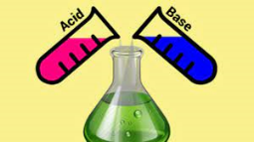
4- Learn about the reaction of acids and bases
5- Learn how salts are named

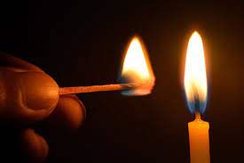
6- Learn about combustion reactions

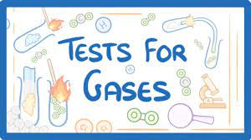
7- Learn how to test gases to identify them
8- Metals test

