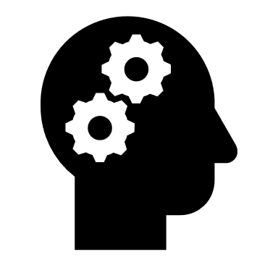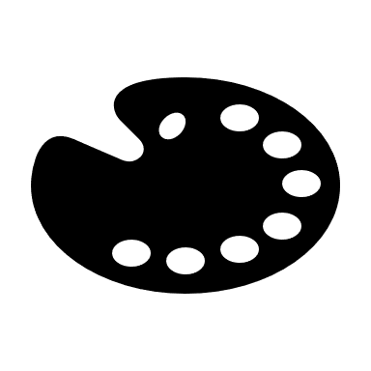

**12/13. Dirt, Photo Weaving and Easter activity**

Skills:

Paper weaving

Personal Response

**11. Photo Weaving**

Skills:

Paper weaving

Personal Response

**10. Artist research page Nilupa Yasmin**

Skills:

Weaving

Pattern

Personal response

**9.** **Artist research page Nilupa Yasmin**

Skills:

Weaving

Pattern

Personal response

**7. Gallery visit virtual/in person**

Skills:

Observation

Mark-making

Personal response

**8. Dirt and Gallery visit virtual/in person**

Skills:

Exploring artist’s work

Personal response

Critical thinking

**4. DIRT and Mixed media Artist study**

Skills:

Observation

Artist’s work

Personal response

**3. Artist Research Sheet**

Skills:

Observation

Artist’s work

Personal response

**2. Collagraph printmaking**

Skills:

Collage

Printmaking

Personal response

**5. Artist inspired mixed media piece**

Skills:

Mixed Media

Personal response

Combined media

**6. Complete own inspired mixed media artwork**

Skills:

Personal response

Critical thinking

discussion and debate

**1. Collagraph printmaking**

Skills:

Collage

Printmaking

Personal response

Learning Journey- *Year 8 Art Term 3&4*