Year 11 French – Spring 1 –

My studies, Life at school/college



On to describing

Education post-16,

Jobs, career choices and ambitions

Assessment & DIRT

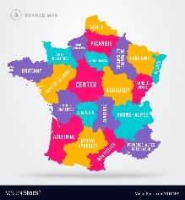

Revision –

What do I know?

Describing a typical school day

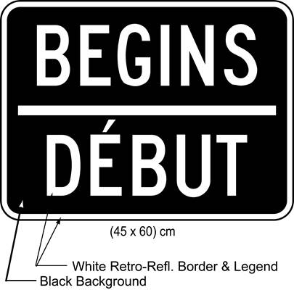

Talking about school uniform and timetables

Describing your school

Giving opinions about school