27th April 2022
Dear Parents and Carers,
We are delighted that your child has been offered a place at Pewsey Vale School for September 2022 and we would like to take this opportunity to welcome you and your family into our community. We have set up a page on our main school website in order to aid the transition process where you will also find a copy of this letter. Over the coming months, we will regularly update this page with all the relevant information relating to your child starting school with us in September.
As a school, we aim to support both you and your child through the process of transition to make it as smooth as possible.
In order to aid transition, we intend to provide the following programme:
- May - an online admissions and information form will be sent to all parents which we would ask you complete for your child/ren. We use this as an opportunity to offer you a chance to share useful information with us about your child so that we are able to best support them from the moment you join us.

- End of May - we will be sending out a complete transition pack with a wealth of information regarding our school to guide you during this period including a student activity pack.

During June we will visit all the students in their primary schools so that we can find out about them and answer any questions or address any concerns they may have. We will also be holding a Transition Day at Pewsey Vale School on Wednesday 6th July (an alternative day will be advised for students at Pewsey Vale Primary), with a parent’s information evening to be held on the same day.
We wish your child the very best over the coming months and look forward to them joining us for Year 7.
Yours faithfully
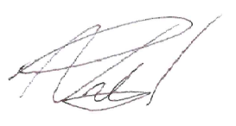
Mr N Pritchard Miss C Dean
Head Teacher Assistant Head Teacher

