June 2024

Dear parent/guardian
We are very excited to invite our new cohort of students, joining us in September 2024, to spend a day with us.
Transition to secondary school is both an exciting and nerve-wracking time and the package we provide is in place to support you through this process; ready to start with us in September.
Our transition event will take place on Wednesday the 3rd July.
This day is a great opportunity for our new students to have their first taste of secondary school life, start to familiarise themselves with the school site and to meet new friends.
In order to keep your child/children safe during the course of the day, we require some up to date information. Please complete the form in the link below:
https://forms.office.com/Pages/ResponsePage.aspx?id=lZBIT9e580SojBnksxfP7OzDjrhwMXlBrC6WVmUhsnhUQ0lXWkowMEtJWDNJVURGUTFVQTRYVElLTy4u
Please arrange for your child to arrive at the school for 9.30am. You will be met at the front of the school and then the students escorted in to their first location for the day where they will be welcomed by the Head teacher.
We ask that students wear their current school PE kit for the visit, and that they bring a pencil case with them for activities they will undertake. Students will also need to bring a packed lunch with them for this day. If your child currently receives free school meals then please talk to their current establishment about provision of a packed lunch for the day.
The school day will finish for the students at 2pm. If you are collecting your child (as indicated in the form) please ensure you arrive promptly; our school buses start to arrive after this point and you will find it more difficult to park/exit the car park.
During the evening we will be hosting an information event for parents/guardians. School will be open from 5.45pm, with a welcome speech from Mr Pritchard at 6pm. There will also be an opportunity to try on the school uniform and PE kit (for sizing purposes) and meet key staff members.
Our first school day for our new year 7 intake will be Wednesday 4th September. We will communicate further information about this with you in due course.
Yours faithfully

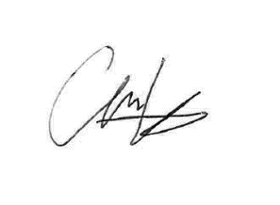
Miss C Dean
Assistant Head Teacher

