Student Edition
Mr. Carter
The Guards series – Terry Pratchett (‘Guards! Guards!’, Men at Arms, Feet of Clay, Jingo, The Fifth Elephant, The Nightwatch, Thud and Snuff)
The Tiffany Aching set (Wee Free Men, The Wintersmith, Hat full of Sky, I shall Wear Midnight and The Shepherd’s Crown)

Mrs. Furness
Treasure Island – Robert Louis Stevenson
The Secret Garden – Frances Hodgson
Tom’s Midnight Garden – Philippa Pearce
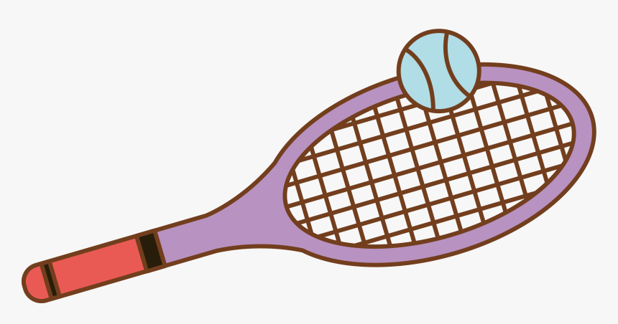
Miss Whitby
The Book Thief - Markus Zusak
A Thousand Splendid Suns - Khaled Hosseini
The Kite Runner - Khaled Hosseini

Ms. Lythe
Red Bird Sings: The Story of Zitkala-Ša - Gina Capaldi and Q. L Pearce
Other Words for Home – Jasmine Warga
Rivers: A Visual History from River to Sea – Peter Goes
The Dragon Slayer: Folktales from Latin America: A TOON Graphic - Jaime Hernandez

Mrs. Scott
Letters from the Lighthouse - Emma Carroll
Ms, Wassell
Klara and the Sun - Kazuo Ishiguro

Mrs. Sheppy
When we were Liars - E Lockhart (for older students)
The Fountains of Silence - Ruta Sepetys (for older students)
When the Sky Falls - Phil Earle
The Girl of Ink and Stars - Kiran Millwood Hargrave
Mr. Andrews
The Miss Peregrines Home for Peculiar Children - Ransom Riggs
The Atlas Six - Olivie Blake
The Witcher Series and Child 44 - (for older students as they contain some violence and more adult themes)
The Perks of Being a Wallflower - Stephen Chbosky

Ms. Protheroe
To Kill a Mockingbird – Harper Lee
The Life of Pi - Yann Martel
Curious Incident of the Dog in the Night – Time - Mark Haddon
I Am Malala – Christina Lamb and Malala Yousafzai

Mrs. Youngs
Wonder - R. J. Palacio
The Choice – Edith Eger
Milkweed – Jerry Spinelli
The Giver- Lois Lowry
When Hitler Stole Pink Rabbit – Judith Kerr
The Humans – Matt Haig
How to Stop Time – Matt Haig

