Year 9 German – Summer 2 – Exam revision and Berlin project

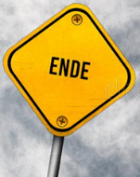

On to Year 10 ☺

Carrying out online research

Planning a presentation

Berlin project

Summer exam



Revision of Daily Life

Revision of Jobs and Future plans

Revision of Holidays

Revision of Where I Live