Year 8 German – Summer 2 – Exam revision and Berlin project

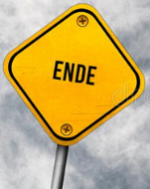

On to Year 9 ☺

Carrying out online research

Planning a presentation

Berlin project



Summer exam

Revision of Daily Life

Revision of Holidays

Revision of Where I Live