Year 8 French – Summer 2 – Food and Drink

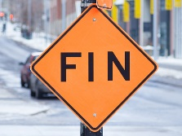

On to Year 9!

Assessment & DIRT

Revision – what do I know?



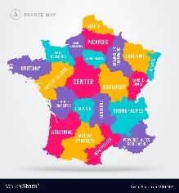

Learning an new tense

Making meal preparations for a forthcoming event

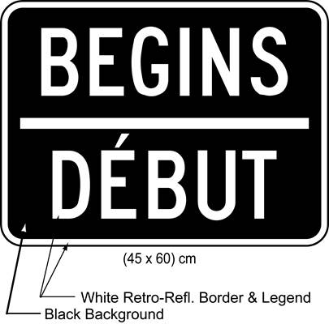

Describe what I eat and drink at different mealtimes

Buying food: Learning about quantities and shopping lists