Year 8 French – Spring 2 – Clothes

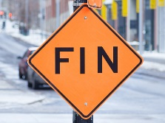

Revision – what do I know?

On to describing different homes

Assessment & DIRT



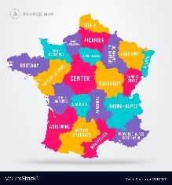

Using 3 tenses together

Describe what I wore

Describing what I (and my friends) did last weekend

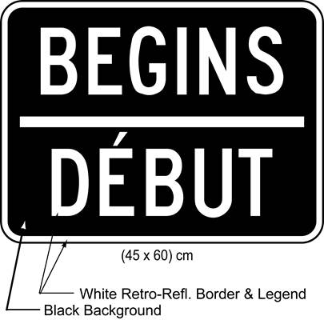

Describe what you are going to wear in the near future

Describe the clothes I’m wearing / usually wear