Year 8 French – Autumn 2 – Paris



On to describing

My identity

Assessment & DIRT

Revision – what do I know?



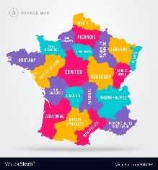

Saying what I did and what I visited in Paris

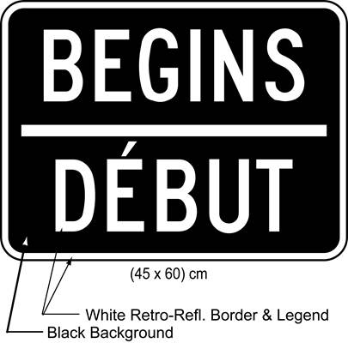

Culture

Saying what you *can do* in Paris

Asking for information at the tourist information office