Year 7 German – Autumn 2 – Describing myself, different

families and pets

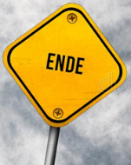

On to describing what I do in my free time

Kultur - Christmas traditions in Germany and Austria

Christmas card competition



Revision

Reading assessment

What do I know?

Describing a photograph of a famous family

DIRT

Dictionary skills

Revisiting the verb sein

Stating the age of family members and friends

Describing the qualities of a good friend

Describing the character of others

Revisiting the verb *heissen*

Forming plural nouns



Recycling language

Revisiting negation

Numbers 1-100

Describing pets

Saying whether or not I have pets

Using possessive adjectives, *“mein, dein”*

Using ***haben*** with the accusative case

Negation

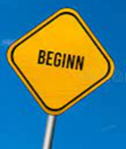

Using personal pronouns

Using conjunctions

Recognising adjective endings

Using

Using ***haben*** and the indefinite article

Asking questions - Using subject-verb inversion

Revisiting definite articles

Revisiting the verb ***sein***

Introduction to Grimm’s fairytale characters

Describing my hair and eye colour

My belongings and favourite things

Introducing other family members

Describing the appearance of family members

Saying whether or not I have brothers and sisters

Describing my height and build

Colours