Year 7 French – SUMMER 2 – Free Time

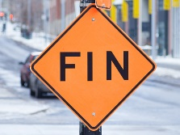

On to talking about where I live

Assessment & DIRT

Revision – what do I know?



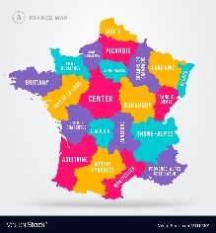

Learning another tense

Describing which free time activities I like and don’t like to do and why (not)

Describing what I (and my friends) did last weekend

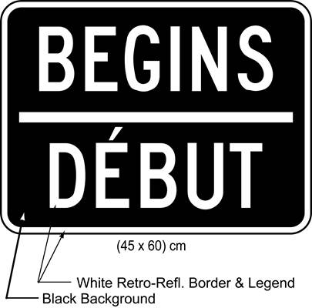

Talking about other free time activities

Describing when and with whom I do sport

Saying what I do on my computer and my mobile phone

Talking about which sports and games I play