Year 7 French – Summer 2 – Holidays

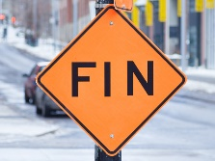

On to Year 8!

Assessment & DIRT

Revision – what do I know?



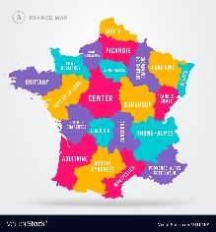

Learning an new tense

Saying where I am going to go on holiday in the future holiday

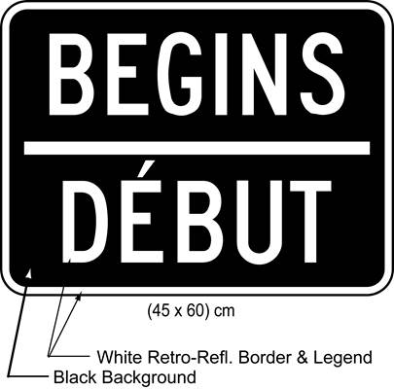

Saying where I usually go on holidays

Learning how to buy snacks and drinks at the beach café