Year 7 French – Spring 1 – School



On to talking about Free Time

Assessment & DIRT

Revision – what do I know?



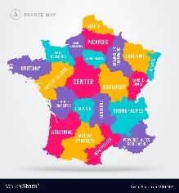

Describing my school day

Comparing school in the UK to school in France

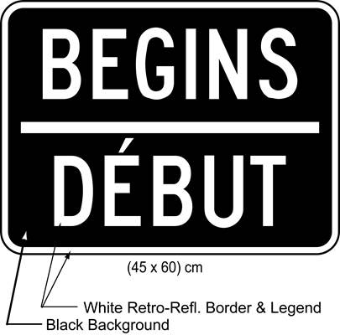

Talking about my timetable

Telling the time

Saying which school subjects I learn

Talking about which school subjects I like and don’t like and why (not)