Year 7 French – Autumn 2 – Myself and my family



On to describing

School

Assessment & DIRT

Revision – what do I know?



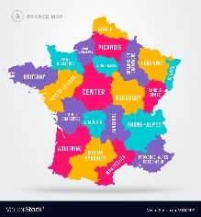

Culture

Describing the personality of others

Describing my personality

Learning about Christmas in France

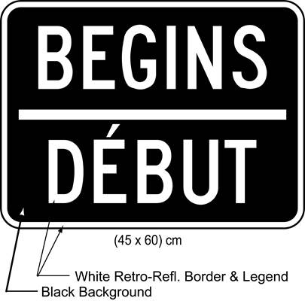

Describing the appearance of others

Talking about my height and build

Talking about brothers and sisters

Talking about my hair and eye colour