Year 8 – Space Learning Journey
Lesson | Oi! Remember this!
1.) Describe the Hierarchy of the Universe.
 | Universe, Galaxy, Solar System, Star, Planets, Moons, satellites.
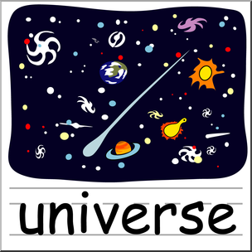
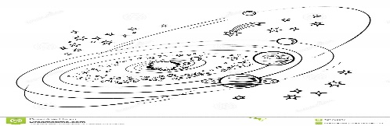
2.) Movements of the Earth and Moon
 | The Earth orbits the sun in 365^{1/4} days (year) spins on its axis in 24 hours (day) and the moon orbits every 28 days .
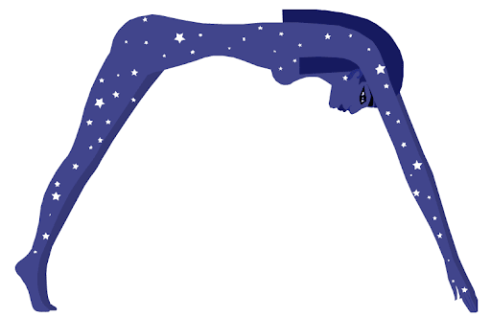
3 & 4.) Changing ideas over time…
 | Ideas about the Universe have changed dramatically over time…new ideas are based on evidence.
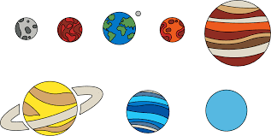
5.) Planet research
 | Detailed knowledge about one particular planet.
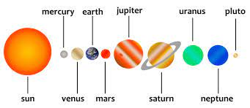
6.) The Solar System (feedback from 5)
 | A planets’ defining features are dependent on the distance of it form the sun. My Very Easy Method At Jumping Streetlamps Usually Needs Pads.
7.) Atmospheres
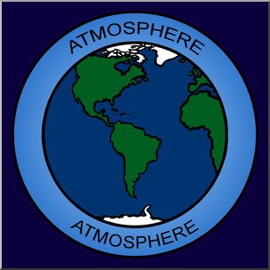 | Atmospheres are layers of gas around a planet. They can help heat the planet.
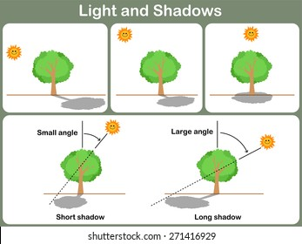
8.) How height of the Sun effects the length of shadows.
 | The higher the sun in the sky the smaller the shadow cast.
9.) Phases of the Moon.
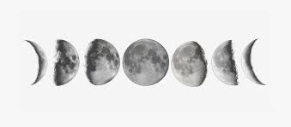 | Moon reflects suns light as it obits the Earth which produces ‘phases’. New, Crescent, half, Gibbous, Full and back.
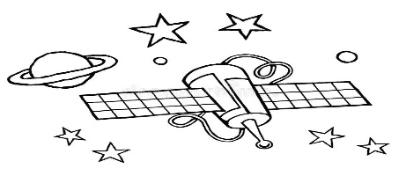
10.) Satellites and their uses.
There are different types of Satellite; low polar, geostationary, natural etc.
KS2 – Day and year length.
8 – Shadow formation from Light & Sound.
EXAM 3 Assessment

