Year 7 Forces- Learning Journey
Lesson Oi! Remember This!
1) Name friction, air resistance and weight as forces and describe their effects

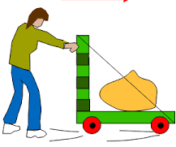
2) Know that when a force is applied work is done and an energy transfer takes place
3) Recognise that when a force is placed upon a spring it extends, and that the extension is proportional to the force applied.
4) Write up a practical including an aim, hypothesis, method, diagram, results, line graph and conclusion

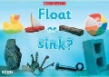
5) Explain that some objects float or sink and it depends upon the density of the object and liquid
6) Use the idea of forces and density to explain why some objects float or sink

7) Understand that forces act in pairs, can be balanced or unbalanced and what the effect of forces are on motion
8) Represent balanced and unbalanced forces using force diagrams and calculate resultant forces
9) Know that mass is the amount of matter in an object, measured in g or kg, and weight is a force of an object’s mass acted upon by gravity, measured in Newtons.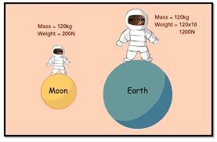
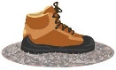
10) Know that friction is a force that acts against an object’s motion and that it slows objects down
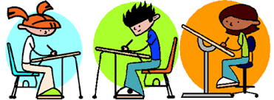
12) End of topic test

Gravity is a force that pulls on an object’s mass
Forces can affect an object’s motion
Upthrust is a force which keeps things afloat in water
Forces can change an object’s speed, shape or direction

When work is done on an object because a force is applied, the object can change shape

Hooke’s Law shows that when a force is applied to a spring, it will extend. The extension is proportional to the weight on the spring
Forces can act on an object, slowing it down
If forces are the same size and opposite in direction they are balanced. If they are no the same size, opposite forces are unbalanced
Objects can float or sink depending on how dense they are compared to the liquid they are in

