Year 9 Metals and Acids Learning Journey
Lesson Remember this!
Mixtures made of a solid dissolved in the liquid can be separated
Some mixtures are made up of different liquids or dyes that can be separated
Pure metals are not a mixture and have distinct physical properties
Mixtures are made of different substances mixed but not chemically joined
Elements are made of one thing and mixtures are made of more than one substance mixed
Elements are made from one type of atom and all elements are listed on the periodic table
The periodic table is an arrangement of all of the elements
Metals show different reactivities

Some metals are more reactive than others

Some metals will react with other substances to form a new product called a compound
How reactive a metal is can be found out by looking at its place on the reactivity series
Some metals are too reactive to extract using reduction

Knowledge from the previous 13 lessons!

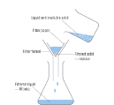
1- Separate a mixture
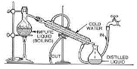
2- Learn about separating a mixture using distillation
3- Learn how to separate a mixture using chromatography
4- Compare the properties of metals and non metals
5- Learn about alloys

6- Learn about the difference between atoms, elements, compounds and mixtures
7- Learn about how the periodic table was made
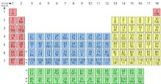
8- Learn about patterns in the periodic table
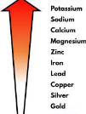
9- Learn about the reactivity series

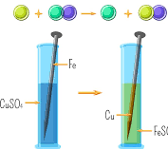
10- Learn about displacement reactions
11- Learn about how metals react with oxygen
12- Learn how to use the reactivity series to work out how a metal is extracted
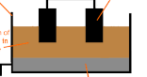
13- Learn about electrolysis as a way to extract more reactive metals
14- Metals test

