Year 8 Light - Learning Journey
Lesson | Oi! Remember this!
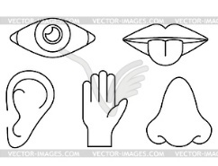  1.) Recognise Sense Organs | Sense organs pick up energy
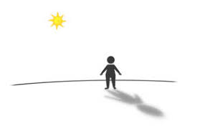  2 & 3.) Light causes shadows | Light travels in straight lines and is absorbed by dull objects
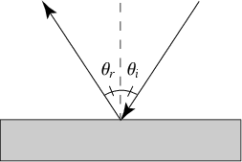  4 & 5.) Law of Reflection and periscopes | Angle I = Angle R
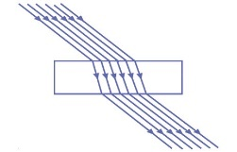  6.) Refraction | Light can pass through transparent objects
7.) Refraction through a prism | Light is bent when its speed is changed
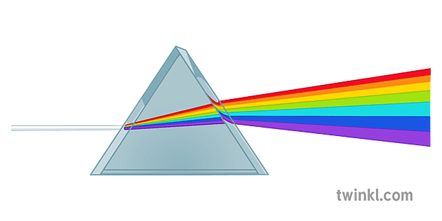
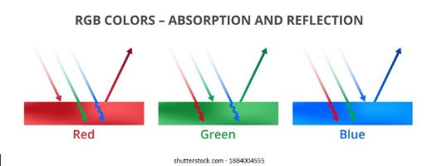  8.) Why objects are coloured | White light is a mixture of colours
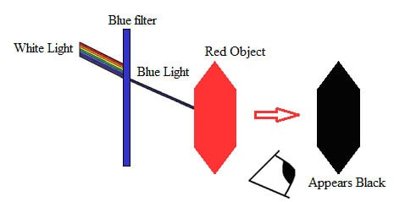  9.) Coloured filters | Light can be manipulated by filters, lenses etc.
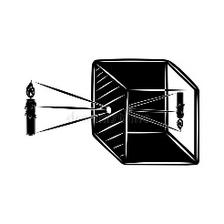
10.) Pinhole camera | Light can be projected onto a screen
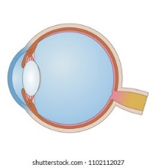
11.) Eye function

Synoptic Assessment (after Sound)

