Year 9 – Photosynthesis Learning Journey
Lesson | Oi! Remember this!
1.) All food chains start with Photosynthesis.
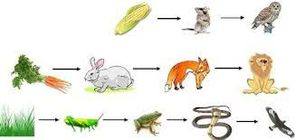 | Plants produce food using Photosynthesis (p/s)
2.) Structure of leaves.
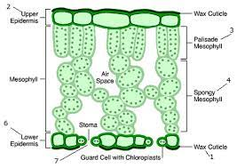 | Leaves are adapted to trap light and allow gaseous exchange for p/s.
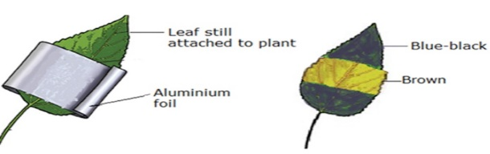
3.) Testing leaves for Starch.
 | If plants complete p/s they will store Starch; Iodine goes Blue/Black from Brown.
4.) Testing variegated leaves for Starch
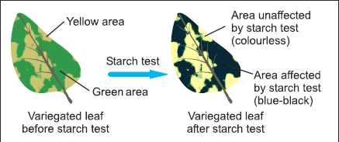 | Variegated leaves lack chlorophyll in white parts; no starch produced here.
5.) Photosynthesis producing Oxygen
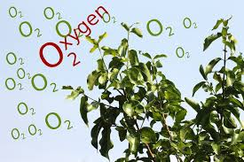 | Oxygen is a by-product of p/s, turns bicarb indicator purple.
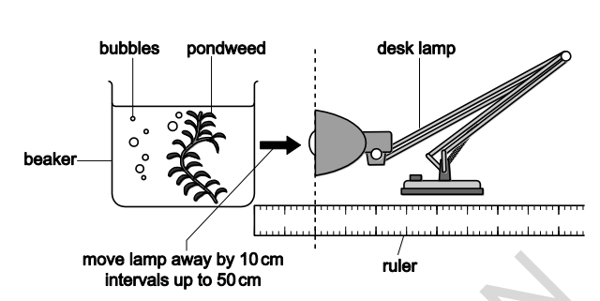
6, 7 & 8.) Photosynthesis Investigation.
 | Closer to the light source more Oxygen bubbles produced.
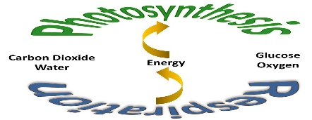
9.) Comparing Respiration and Photosynthesis.
 | Respiration and p/s are opposite reactions.
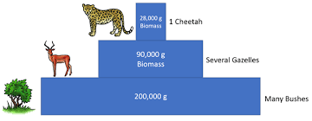
10.) Constructing Food Pyramids.
 | Food chains – pyramids, number of links = number of blocks and to scale.
11.) How Humans impact food chains.
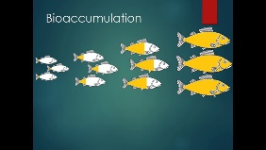 | Humans can impact food chains which then have further impacts.  7 – Cells and Classification, Body Systems, Environment.  8 – Environment 2, Materials and Substances.
12.)Synoptic Assessment

