Year 8 Heat Transfer Learning Journey
Lesson Remember this!
Heat is a type of energy which can change the temperature of a substance
In a solid, particles are in a fixed arrangement and can only vibrate
In liquids and gases particles are able to move

Conduction and convection requires particles

Heat can travel by conduction, convection and radiation

When energy is transferred some is often wasted as heat

Insulation can reduce heat transfer
Insulation can reduce heat transfer
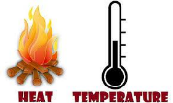
1- explain the difference between heat and temperature
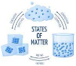
2- describe changes of state as energy transfer
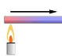
3- explain conduction in terms of energy transfer and particles
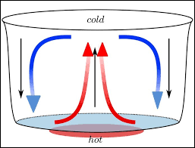
4- explain convection in terms of energy transfer and particles

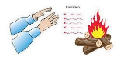
5- explain heat transfer by radiation

6- identify areas of energy loss or wastage in a home and identify solutions
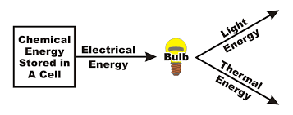
7- identify energy wastage in energy transfers and how to improve efficiency
8- investigate the effectiveness of cotton wool, newspaper and bubble wrap as insulators.
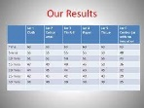
9- evaluate the effectiveness of different forms of insulation by analysing experimental results

