Year 7 – Acids Learning Journey
Lesson | Oi! Remember this!
1.) Reversible/irreversible reactions | Chemical change is irreversible and new products are made.
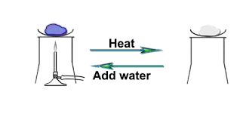
2.) Reactions of Acids | Acids are a family of chemicals and show similar reactions.
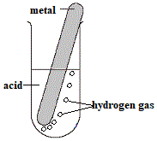
3.) Indicators and the pH scale | Indicators change colour in acids and alkalis and are used to determine a substances place in the pH scale.
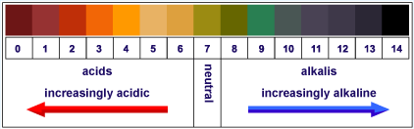
4.) Neutralisation of acids | All Acids react to form a neutral substance/solution.
5.) Plan Indigestion investigation | Indigestion is caused by stomach acid.
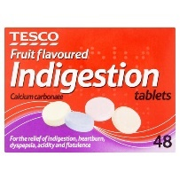
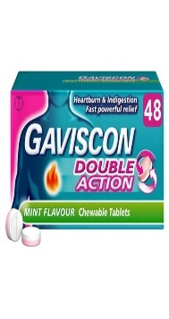
6.) Collect evidence for investigation | The best remedy is the best at neutralising the acid.
8.) Concluding investigation | Neutralisation is getting rid of the H⁺ ion/the acid
9.) Synoptic Assessment

